**Step 1: Configure the Bucket for Static Website Hosting**

1. **Open the AWS Management Console**.
2. **Navigate to the S3 service**:
   * In the AWS Management Console, search for and select **S3**.
3. **Select Your Bucket**:
   * Click on the name of the bucket you created (e.g., xyz-corporation-file-storage).
4. **Enable Static Website Hosting**:
   * Go to the **Properties** tab.
   * Scroll down to the **Static website hosting** section.
   * Click on **Edit**.
   * Select **Enable**.
   * **Index document**: Enter index.html.
   * **Error document**: Enter error.html.
   * Click on **Save changes**.

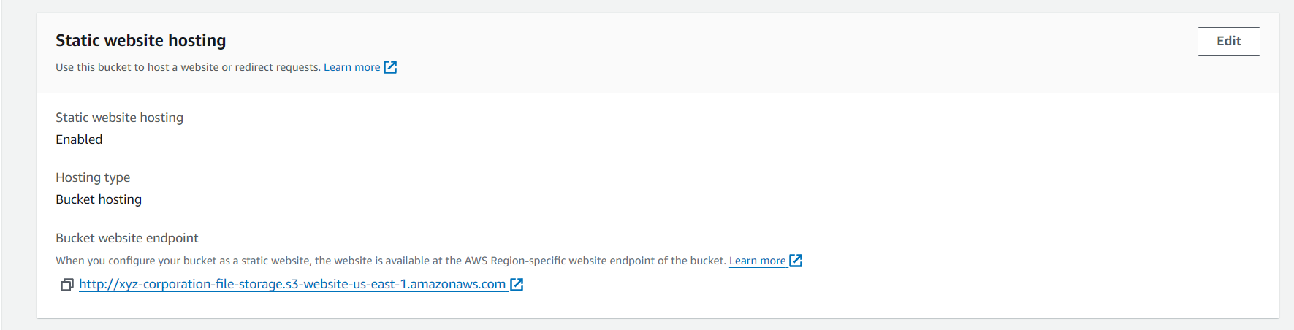

**Step 2: Upload the index.html and error.html Files**

1. **Upload Files**:
   * Go to the **Objects** tab in your bucket.
   * Click on the **Upload** button.
   * Click on **Add files** and select your index.html and error.html files.
   * Click **Upload**.

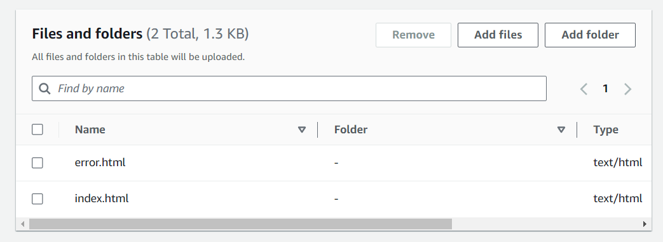

**Step 3: Set Permissions for Public Access**

1. **Set Permissions**:
   * After uploading the files, select each file and go to the **Permissions** tab.
   * Under **Public access**, click on **Edit**.
   * Select **Grant public read access to this object(s)**.
   * Click on **Save changes**.

**Step 4: Add Lifecycle Rules**

1. **Navigate to the Management Tab**:
   * With your bucket selected, go to the **Management** tab.
2. **Add Lifecycle Rule**:
   * Click on **Create lifecycle rule**.
   * Enter a **Rule name** (e.g., TransitionAndExpirationRule).
   * Choose **This rule applies to all objects in the bucket** (or you can specify a prefix if needed).
   * Click **Next**.
3. **Set Transition Rule**:
   * Check **Current version** and select **Transition to Standard-IA storage class**.
   * Set the transition to occur **60 days after creation**.
   * Click **Next**.

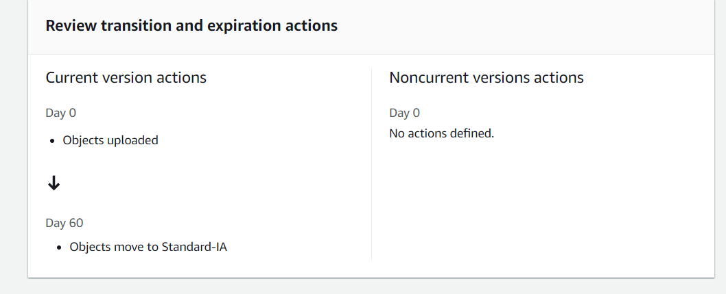

1. **Set Expiration Rule**:
   * Check **Current version** and select **Expire current version of objects**.
   * Set the expiration to **200 days after creation**.
   * Click **Next**.

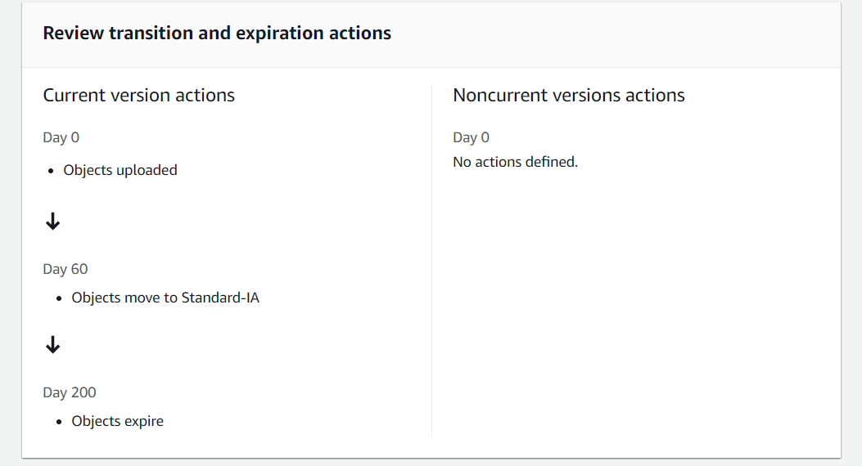

1. **Review and Create**:
   * Review the lifecycle rule settings.
   * Click on **Create rule**.

**Step 5: Verify Static Website Access**

1. **Access Your Website**:
   * Once everything is set up, go back to the **Properties** tab of your bucket.
   * Under **Static website hosting**, you'll find the **Bucket website endpoint**.
   * Copy and paste this URL into your browser to access your static website.

